**The 3D Pac Man Project**

[](https://github.com/NRais/Building-In-Unreal/blob/main/PacManProject/Readme/header.jpg)

[*https://github.com/NRais/Building-In-Unreal/tree/main/PacManProject*](https://github.com/NRais/Building-In-Unreal/tree/main/PacManProject)

*Designed by Nathanael Rais*

[Assignment 1: Course Comp313: CRN 25049](https://github.com/NRais/Building-In-Unreal/tree/main/PacManProject)

PAC MADMAN is a reinventing of the classic arcade game Pacman. Complete with all the features the original game had, Pac Madman brings a new life and variety to a beloved classic. With over a dozen levels this game is engaging and easy to play. But watch out, the Ghost get bigger when you kill them...

[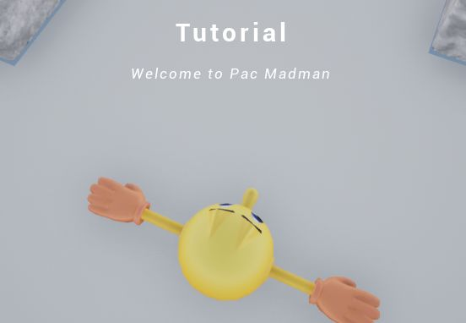](https://github.com/NRais/Building-In-Unreal/blob/main/PacManProject/Readme/intro.jpg)

# What is the main action in the game?

Pac Madman is a game built around running from ghosts and collecting power ups. Designed with a top down camera this game has the feel of many traditional 3rd person games with the intensity and thrill of interaction and levels.

Pac Madman adds to the action of the traditional arcade game with unique map environments, enemies and power ups to add a variety to the levels and more strategy.

* Control system (Player choices and level design)
  + Level progression (8 unique levels)
  + Maze-style maps
  + Power ups (4 unique pickups)
  + NPC design (unique AI)
* Score tracker
* Limited re-spawns (after 3 deaths you have to restart from the beginning)

# What was the hardest part of the game to get working in Unreal?

Working in Unreal streamlines a lot of processes. Great parts where how easy it is to build a UI or menu and how no effort is required for simple AI path finding. However, the downsides where definitely visible as well.

Getting started in a new environment is always a learning curve and Unreal brought a new IDE, a new language (blueprints) and a new style of design (3D). Just knowing what to type into the search bars was hard and the official documentation is lacking for generic "how do I do this" type questions.

I found it quite difficult to know what I needed to know starting out but after a number of tutorials I started getting a feel for the way blueprints and UE4 was laid out and from there I could begin intelligently implementing features.

# What is the most interesting part of the game?

For me the most interesting part was expanding beyond what normal pac man could do. Customisation and cool features included:

* Special effects (tornado's, glowing power ups, teleporters, terrain)
* 3D world interactions (collisions, jumping, on overlap events)
* Power ups (speed boosts, power pickups and even more interesting strategic pickups that you have to time right)
* Enemies (going beyond standard ghosts to whirlwinds that grow, terrain that attacks you, and even more)
* Levels (With 4 starter levels, 4 advanced levels and 4 randomized levels the game has a lot of playability!)

However, of the game's fun came through actually designing it. Using UE4 is incredibly powerful and lets you exponentially expand your aims for what you want to achieve in a game. Being able to express this creativity was really enjoyable.

# Marking Scheme

Find below a list of features matching each criteria.

[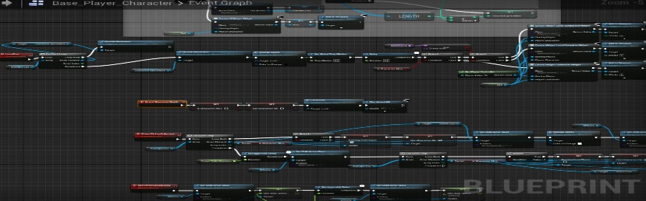](https://github.com/NRais/Building-In-Unreal/blob/main/PacManProject/Readme/blueprints.jpg)

[](https://github.com/NRais/Building-In-Unreal/blob/main/PacManProject/Readme/pacman.jpg) **Control a character on screen**

* Simple 3rd person player movement
* Arrow key functionality and jumping

[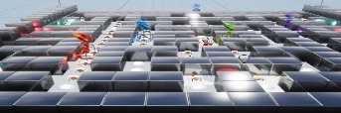](https://github.com/NRais/Building-In-Unreal/blob/main/PacManProject/Readme/control_system.jpg) **Control system**

* Player choices (direction, power ups)
* Level design (maze)
* Level progression (4 intro levels, 4 advanced)

[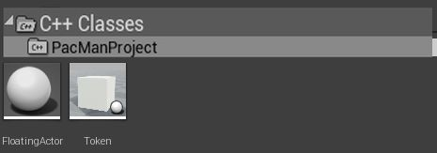](https://github.com/NRais/Building-In-Unreal/blob/main/PacManProject/Readme/c%2B%2B_class.jpg) **Create at least one blueprint node in C++**

* Floating Box actor class
* Animated box that blocks doorways and moves occasionally

[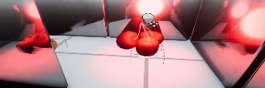](https://github.com/NRais/Building-In-Unreal/blob/main/PacManProject/Readme/cherries.jpg) **Have a character interact with objects in the world**

* Pickups (dots, power, speed, cherries)
* Enemies (4 types of enemies which respond to player actions)
* Environment (teleporter/boxes)

[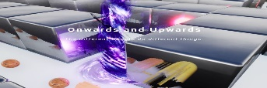](https://github.com/NRais/Building-In-Unreal/blob/main/PacManProject/Readme/animations.jpg) **Animations**

* Menu fade in animations
* Monster animations

[https://github.com/NRais/Building-In-Unreal/raw/main/PacManProject/Readme/score.jpg](https://github.com/NRais/Building-In-Unreal/blob/main/PacManProject/Readme/score.jpg) **Change score on screen**

* Score tracker (top left)
* Life tracker (top right)

[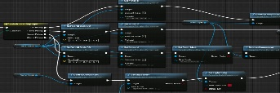](https://github.com/NRais/Building-In-Unreal/blob/main/PacManProject/Readme/assets.jpg) **Manage assets and how they are created and removed**

* Asset construction (monsters/pickups)
* Asset destruction (removing meshes on collision, clearing objects that are picked up)
* Enum design (pickups and terrain is built around enums for easy construction)

[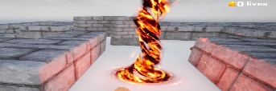](https://github.com/NRais/Building-In-Unreal/blob/main/PacManProject/Readme/npc.jpg) **Move NPCs around**

* AI design
  + Chase player
  + Run from player
  + Re-spawn pause
* AI customization (speed, chase delay, etc.)

[](https://github.com/NRais/Building-In-Unreal/blob/main/PacManProject/Readme/restart.jpg) **Restart a level**

* Upon defeat you may restart as long as you have lives
* Otherwise the game begins again at the start
* 3 widgets used to handle end-game conditions

[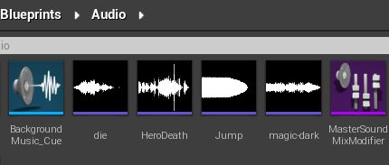](https://github.com/NRais/Building-In-Unreal/blob/main/PacManProject/Readme/sound.jpg) **Play sounds**

* Pickup/Monster/Action sound effects
* Random background music
* Sound mixers used to control effects/music volume

[](https://github.com/NRais/Building-In-Unreal/blob/main/PacManProject/Readme/settings.jpg) **Create a settings menu with**

* Two sliders for volume
* A toggle interaction for changing screen resolution

[](https://github.com/NRais/Building-In-Unreal/blob/main/PacManProject/Readme/victory.jpg) **Show a final screen**

* Defeat screen and Victory screen
* Life and Score stats transferred via GameInstance

**Documentation**

* Commits
  + Commits can be viewed for a clear history of this projects development
  + *Please note: difficulty uploading too large files meant that a large number of commits had to be rolled back and recommitted today*
* Q&A Documentation
  + OneNote project that contains documentation that I made as I learned unreal (Building-in-Unreal > StartingWithUnreal)
* Comments
  + Within the blueprint classes are comments that document what the actors do

[*https://github.com/NRais/Building-In-Unreal/tree/main/PacManProject*](https://github.com/NRais/Building-In-Unreal/tree/main/PacManProject)